**ANDROID AND WEB BASED LECTURER NOTES APPLICATION**

**Ashwani Kumar, Divyanshu Srivastava, Abhishek Sethi, Govind Narayan Jha**

Department of Computer Science and Engineering,

IMS Engineering College, Ghaziabad, Uttar Pradesh, India

Email:ashvaniupadhyay22@gmal.com, srivastavadivyanshu109@gmail.com, abhishek200496@gmail.com, jhagovind096@gmail.com

**ABSTRACT**

In the last few years due to the improvement of the technical education system in India has developed. Smart Class, video conferencing is some of the examples of modern trends in the educational system. helps the institute to move forward, fulfill their vision to accomplish their goals. It provides lecture notes on the basis of their subjects. Teachers will be provided with the separate username and password to upload assignment and mark attendance on a daily basis. It helps the teacher to take attendance through their smartphone and to keep the record of the attendance and notes in their pocket for any time use.

**1.INTRODUCTION**

Mobile technology has been helping to tackle almost every problem that humans face today. Evidently, since the start of mobile applications their usage has been tremendous so much that more than 78% of human activities on smartphones has been on applications [1]. Mobile applications have been an integral part of our life in several ways starting from helping us to connect to people, making money transactions to keeping us healthy by exercising. Now-a-days mobile applications have become very popular for learning new things[2]. Due to such boundless usage, mobile application technology definitely provides us with a platform to solve a major problem faced by everyone student in the world and that is searching lecture notes.[2]

The aim of the application is to develop a platform where students and professors can come together on a single platform to share their ideas, work. So that if someone wants to search for a Lecture Notes does not have to waste time by searching the whole google. We have divided our project into two class one for College purpose and other for individual purpose combining these two categories into one single application.

We developed an Android application for general purpose where anyone can register them self and take lectures notes offline. The main functioning of android application is

1. Students download lectures notes in one click.
2. Students download assignment in one click.
3. Students can also access their college portal with the help of the application.
4. Students can also able to manage their attendance with the help of the application.
5. Students can also upload their favorite subject notes.
6. Students can ask a question to any user of the application

**2. RELATED WORK**

The application we present here is adequate for searching and download notes in offline mode Notes are available for all subject from the first year to the final year of the computer science department. The major concern about this method is that; this system is more time consuming and consumes [2]. We have developed an application for both types of user android based and web-based. Many applications available on plays store which are proving same

functionality and features like Lecture Notes application but they give the services to the user in the place money or monthly subscription and we are providing all the functionality without any cost.

**3**. **PROPOSED WORK**

The application can be installed in any Android phone and required a machine with Pentium IV processor, 512 MB ram, 1GB storage to implement the system and for web application you just need an computer. The application is implemented in Android studio version 2.3 and debug in sdk version 26 minimum sdk version is 19, maximum sdk version is 29, Android application is not working in android version lesser than 19

The Use Case diagram is use to represent all the use cases along with their relationships. The use cases are Register with, files, notes, images, upload, download. Details and the include and extends relationship is as depicted in the figure below.

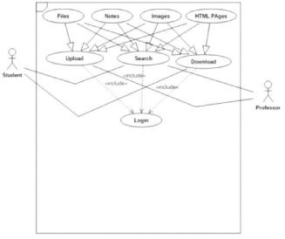

Figure 1. Use case diagram

**4. IMPLEMENTED MODULES**

The main intention of the proposed application is to save the time of students and remove the dictation between the students and teachers from the classroom. Basically, application consist number of modules.

**4.1 REGISTER MODULE**

The main goal is to register the user, irrespective that the user is some professional or Student. The registration is carried out in a way that user Interface is been provided to the user in such a way that user have to mention such defined information such as name, E-mail, password. After filling such information once the user submits the information, the user has to login in the application and provide the e-mail and password after successful authentication user is able to access the application

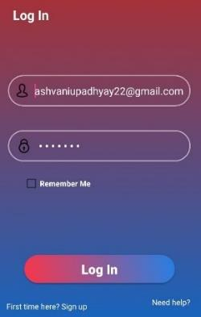

Figure 2. Login screen

**4.2 LOGIN MODULE**

The main goal is to provide authentication to the application, so if any user wants to access the application firstly the user has to provide the mentioned information such as name, password. After filling such information that information is been verified with the information stored in the database. If that information matched with the stored information then only the user get the login and allowed to use the application. Otherwise, the user login gets unsuccessful and returned back to the login page provided that message that information is incorrect.

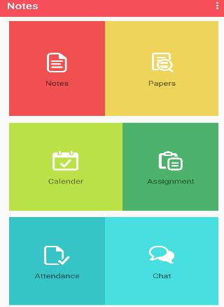

Figure 3. Main Interface

**4.3 FORGOT PASSWORD MODULE**

The main goal is to reset the password of the user, in order to provide reliability to the user. As sometimes it happens that the user forgot his/her password. The password module works in such a way that firstly the user clicks on the forgot password. After that, the user got the link to the registered E-mail id. After visited on that link the user got the page on which the new password can be set.

**4.4 NOTES & PREVIOUS YEAR PAPER MODULE**

The main goal is to provide the college notes and previous year paper to all the students. So that the students will get all the notes and previous year paper easily without wasting their precious time. Sometimes it happens that students don’t get the notes at a specific time and they waste their time by finding the best notes and due to this they waste their lot of time. So, by this module, they can save their lot of time and can get a good score in Exams.

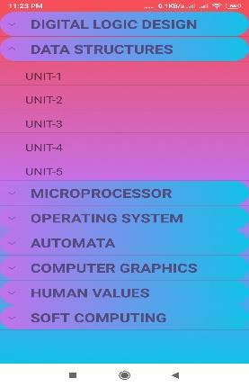

Figure 4. Collection of notes screen

**4.5 UPLOAD MODULE**

The main goal is to store the content of the user based on the usage. The user can upload the content such as files, notes. While uploading these contents the user has to mention the name of the file.

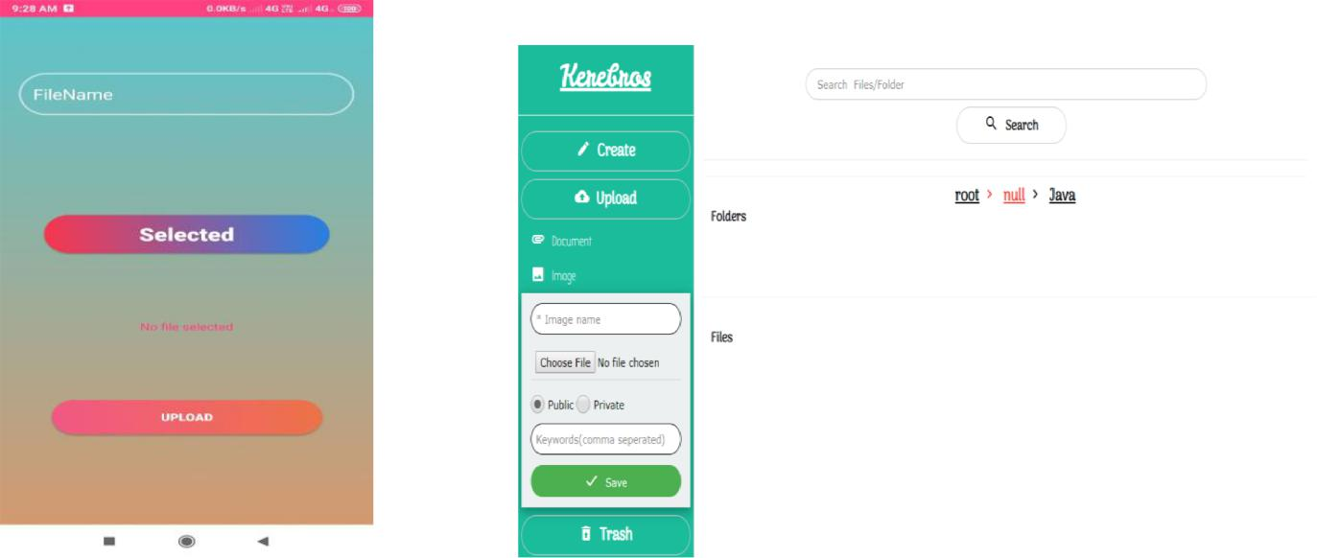

Figure 5. Upload screen

**5. RESULTS**

The system we are presenting is available on play store for better Quality and maintenance we have taken the review and physical review which show how use full our application is Reviews are:

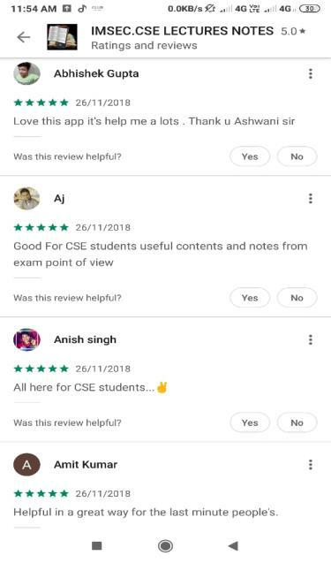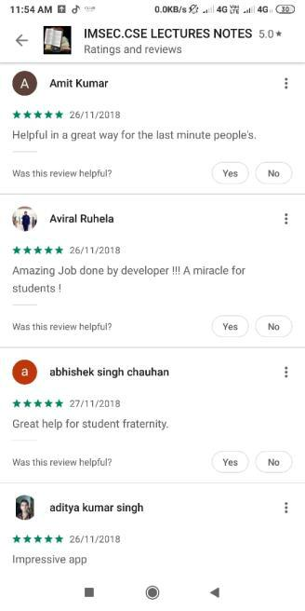

Figure 6. Reviews

**6. CONCLUSION**

The traditional education system for the is more tedious and time-consuming process. With this application we can save student’s and remove the boundation on students to manage attendance in classes. We are trying to bind students and teacher on a single platform and provide best notes to the students.

**7.REFERENCES**

* 1. A. B. Shinde, V. L. Karade, S. S. Sutar, “*Android Based Student Feedback System for Improved Teaching*

1. Sandip Mal, Deepak Gujar, “*Blood Management System Android Application*”, International Journal of

Computer Sciences and Engineering, Vol.7, Issue.2, pp.914-917, 2019.